Define Problem Statements

Date | 28 January 2026
Team ID | LTVIP2026TMIDS66199
Project Name | TransLingua: AI-Powered Multi-Language Translator
Maximum Marks | 3 Marks

Define Problem Statements (Customer Problem Statement Template):

People across the world face language barriers while communicating, traveling, studying, or doing business. Existing translation methods are often slow, inaccurate, or limited in contextual understanding. Manual translation and human translators can be time-consuming and expensive. Many tools fail to provide real-time, context-aware, and multi-language support in a single platform. Users need a fast, reliable, and easy-to-use solution for translating text across multiple languages. Therefore, there is a need for an AI-powered web application that delivers accurate, real-time, and scalable multi-language translation.
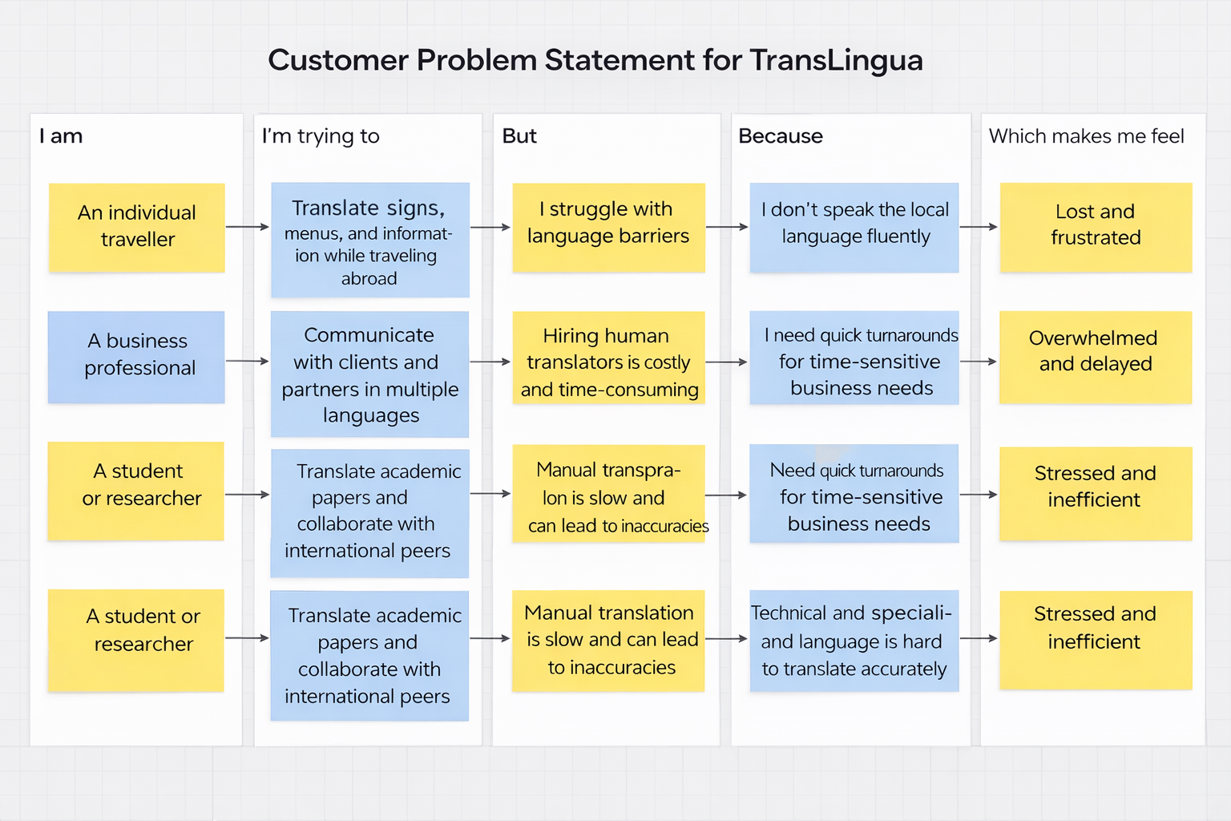
Reference: https://miro.com/templates/customer-problem-statement/

Problem Statement (PS) | I am (Customer) | I’m trying to | But | Because | Which makes me feel
PS-1 | An individual traveller | Translate signs, information while travelling abroad. | I don’t speak the local language fluently. | travel information is scattered and not tailored to my preferences | Lost and frustrated.
PS-2 | A travel agency professional | Communicate with clients and partners in multiple languages. | I need quick turnarounds for time – sensitive business needs. | each client has different preferences and constraints | Overwhelmed and delayed.
PS-3 | A travel content creator or website owner | Translate academic papers and collaborate with international peers. | Need quick turnarounds for time-sensitive business needs. | content creation requires constant research and planning | Stressed and inefficient.

